Algebra 1: Unit 13, Lesson 2

- The graph shows an initial investment of $\$4,000$ in a savings account. The interest rate is $6.25\%$ and is compounded quarterly.
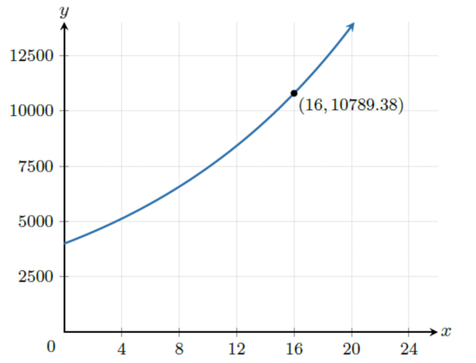
What does the $y$-value of the coordinate, $(16,10789.38)$ represent?
The total amount of money earned.

- The graph shows an initial investment of $\$4,500$in a savings account. The interest rate is $3.25\%$ and is compounded monthly.
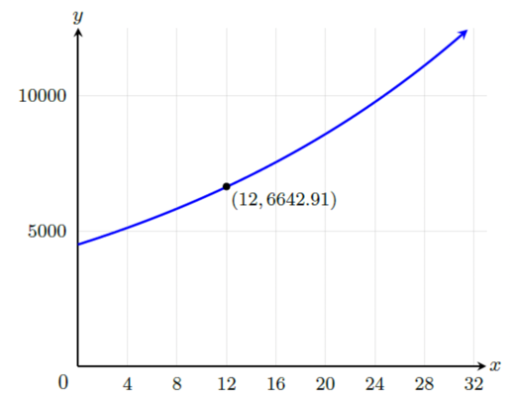
What does the $x$-value of the coordinate, $(12,6642.91)$ represent?
The number of years the amount was invested.

- The equation, $A=1012{\left(1+\frac{0.1012}{6}\right)}^{6t}$can be used to model the total amount in a savings account at a local bank.
What is the final amount in the savings account after 15 years?
$$\$4,559.76$$

